B405 – How to Check Station Info

Find out more information about a Budget rental location. This information includes wizard status, locations belonging to a fleet owner, operation hours, contact information, acceptable credit cards, location-specific fees, fuel prices, special equipment for rental etc.

Mandatory Fields:

ACTION: Enter one of the following actions listed on the main menu
RENT STA: 4-digit Maestro station number or 3-letter mnemonic code

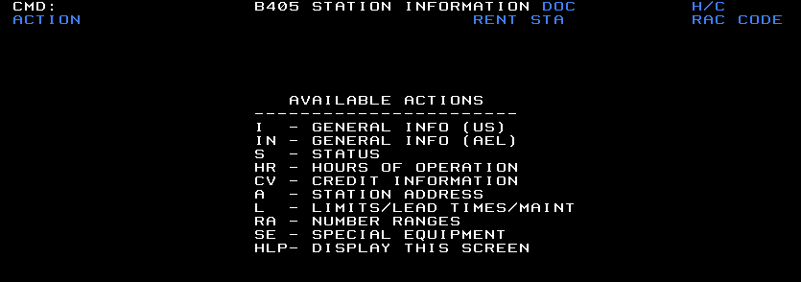

Tip:

- To return to the B405 main menu, enter HLP in the ACTION field.

